Everglades Ecosystem Components

STUDENT PACKET- Introduction to the Everglades Ecosystem: We will define the Everglades as Broward, Dade & Palm Beach Counties
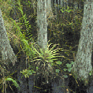 The Everglades' complex ecosystem includes "air plants" that have taken their nourishment directly from the air. These air plants (epiphytes) sprout on rooted plants.
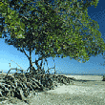 Slash pines like these grow on "hammocks," or small, raised areas in the generally flat Everglades.
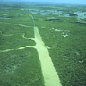 Today, water that once sustained the Everglades is controlled through hundreds of miles of canals and levees. Even the twisting Kissimmee River was "straightened out." The 103-mile-long river often overflowed its banks, until engineers dug a 56-mile-long path for it to take.
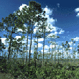 Mangrove trees drop their roots from their trunks and branches into mud. There they grow a tangle of "stilts" and new trunks. Thus the mangrove helps protect shorelines from erosion and helps build new land. In the Everglades, mangroves are threatened by cattails that thrive on water polluted by agricultural runoff.
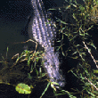
Alligators – another of the Everglades' threatened species- dig deep holes for their nests. Other animals use these holes, which often fill with water, to sustain themselves during dry spells.

